# CS 255 System Design Document Template

## UML Diagrams

### UML Use Case Diagram

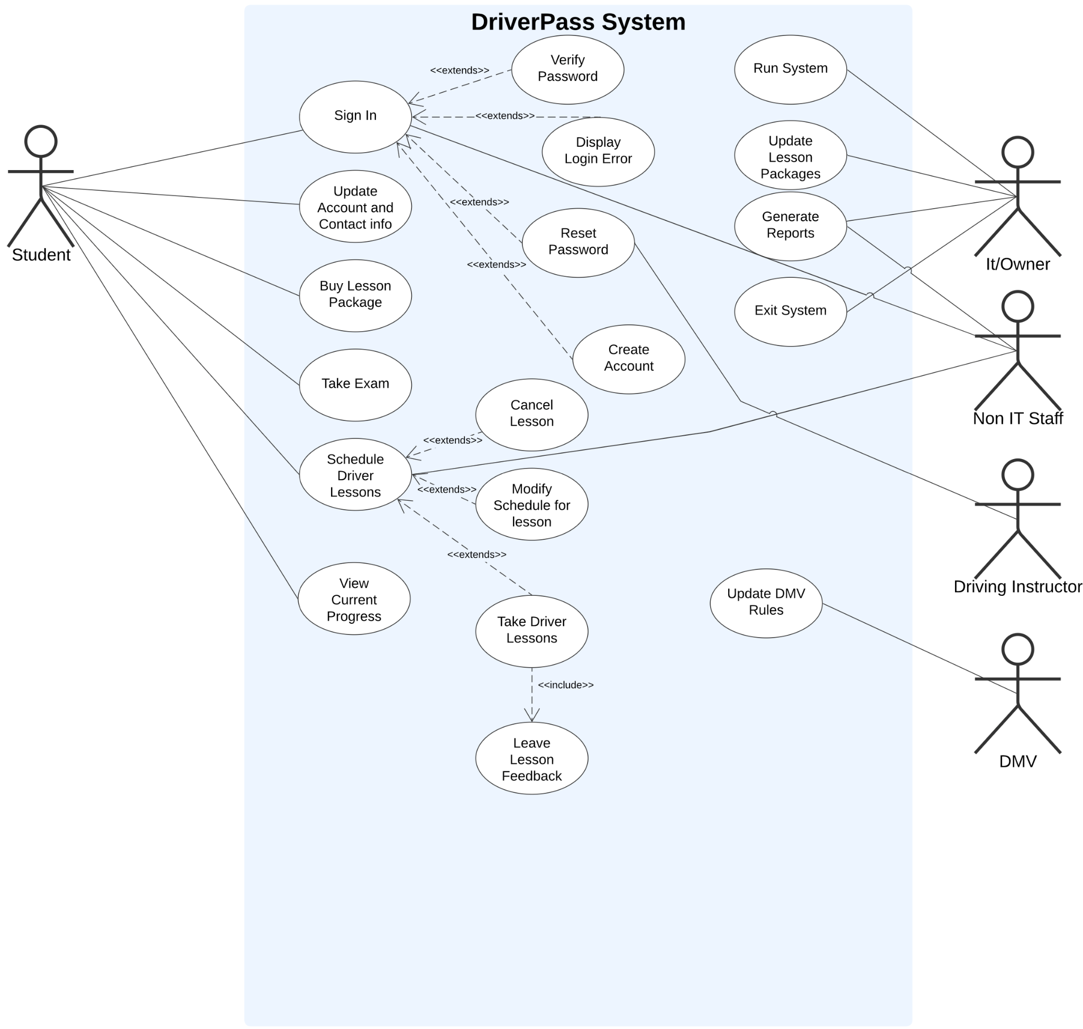

### UML Activity Diagrams

**DriverPass Login UML Activity Diagram**

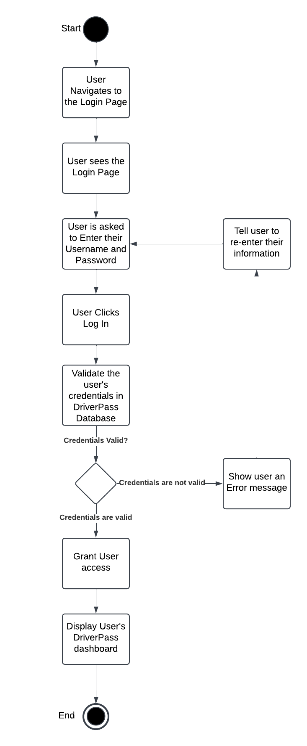

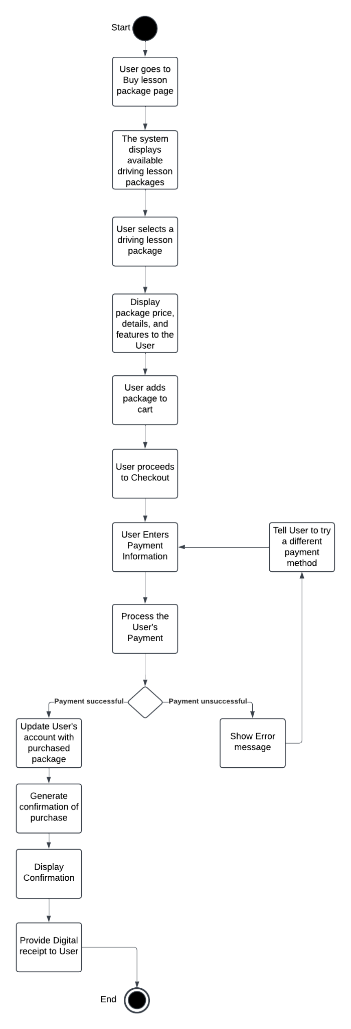

**DriverPass Buy Lesson Package UML Activity Diagram**



### UML Sequence Diagram

**DriverPass Buying a Driving Lesson Package UML Sequence Diagram**

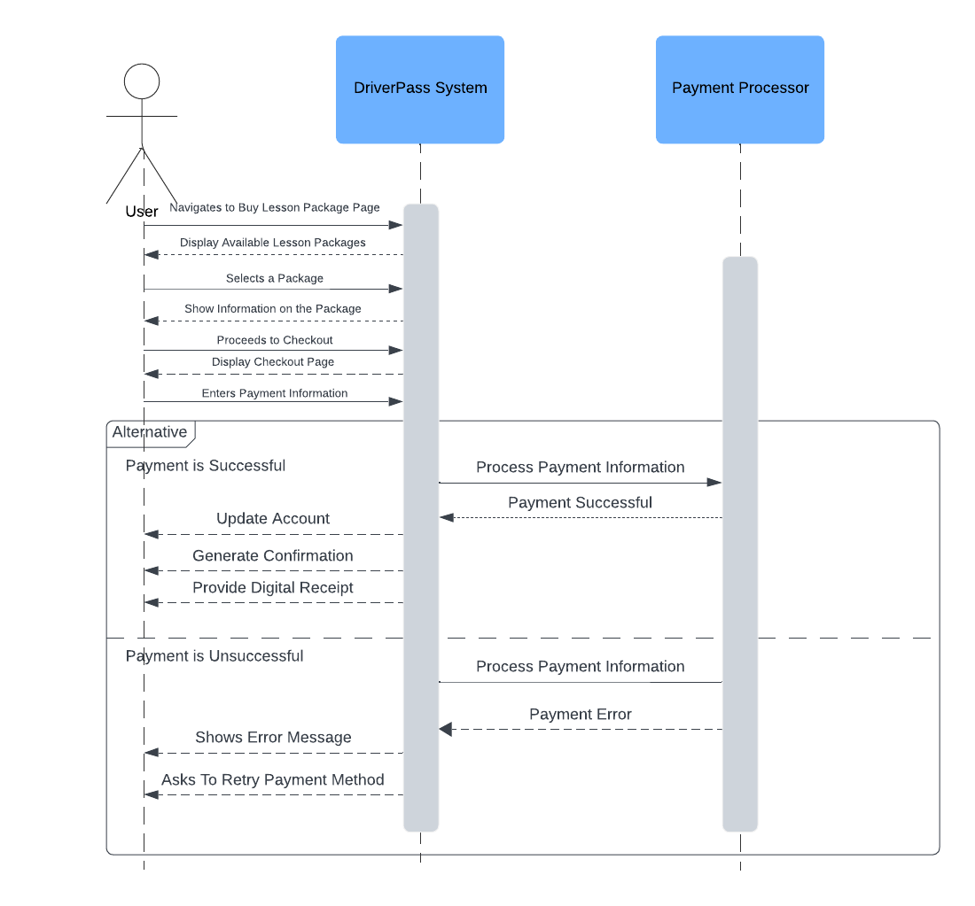

### UML Class Diagram

**DriverPass Class Diagram**

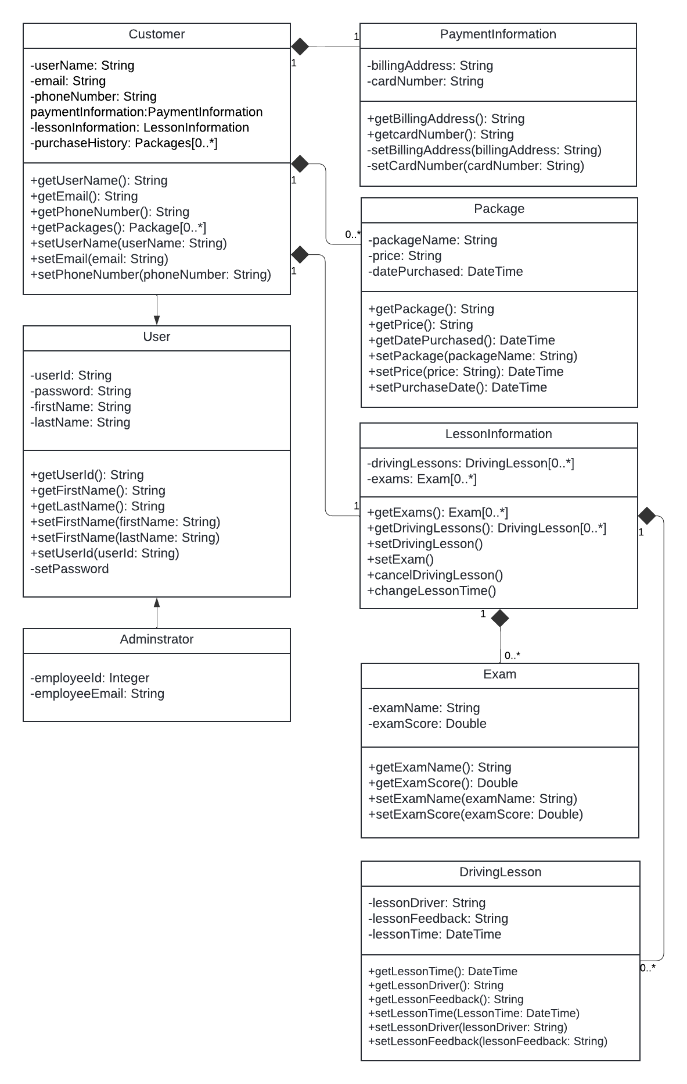

## Technical Requirements

**Hardware**

•A server that can handle concurrent requests from students, instructors, and administrative user

•A database server to store user accounts, lesson schedules, payment records, exam data

•Laptop, desktop, mobile capable of running a standard web browser

**Software**

•An operating system such as Linux

•A web application framework (ASP.NET, Spring Boot, Node.js/Express, Django, etc.) supporting MVC or similar architecture to separate concerns (presentation, business logic, data)

•A database management system (MySQL, PostgreSQL, or MongoDB) capable of supporting transaction integrity and storing relational or NoSQL data, matching the class diagram entities

•A secure payment integration (e.g., Stripe, PayPal, or Braintree) for processing credit card transactions

•IDEs (Visual Studio, IntelliJ, VS Code) and UML/diagramming tools (Lucidchart, Visio) for development and modeling

•A version control system (e.g., Git) to manage code changes and collaboration

•Testing frameworks (JUnit, NUnit, Selenium, Cypress, etc.) for unit, integration, and end-to-end tests

**Infrastructure**

•A cloud hosting environment like AWS

•HTTPS for all login, payment, and sensitive data transfers

•Role-based authentication

•Logging and monitoring for real-time performance metrics, error tracking, and automated alerts in case of issues